2018 - 2019
International Institute of Administration and Business
National Research University
“Higher school of economics”
Moscow, Russia

Advanced Master in International Business

Introduction to HSE University
Consistently ranked as one of Russia’s top universities, the Higher School of Economics is a leader in Russian education and one of the preeminent economics and social sciences universities in Eastern Europe and Eurasia. Having rapidly grown into a well-renowned research university over two decades, HSE sets itself apart with its international presence and cooperation.
Our faculty, researchers, and students represent over 50 countries, and are dedicated to maintaining the highest academic standards. Our newly adopted structural reforms support HSE’s drive to internationalize and the groundbreaking research of our faculty, researchers, and students.
Now a dynamic university with four campuses, HSE is a leader in combining Russian education traditions with the best international teaching and research practices. HSE offers outstanding educational programs from secondary school to doctoral studies, with top departments and research centers in a number of international fields.
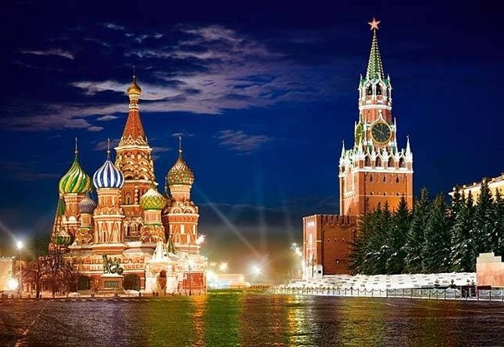
The Higher School of Economics (HSE) has taken place in the QS Top 50 under 50 ranking. Furthermore, it is the only Russian academic institution in this ranking.
HSE’s progress in the global rankings in 2017 can also be seen in the QS BRICS regional ranking, where HSE is now 39th among all universities, moving up 23 positions as compared to last year.
HSE University is situated in 10-minute walk from the center of Moscow – the Red Square and the Kremlin.
Link for more information: https://www.hse.ru/en/info/

Program of professional retraining

“Advanced Master in International business”
Program “Advanced Master in International Business” (AMIB) of International Institute of Administration and Business of HSE (IIAB) is a one and half-year professional retraining program with cross-cultural approach, dedicated to offering a practical business education that will equip students with the knowledge and skills required for success in the international business environment. It provides an excellent connection to the world of business and a solid foundation for an international management career across a wide range of sectors, organizations and positions.
Target audience: graduates fluent in English and with postgraduate professional experience.
Diploma: Advanced Master in International Business (Diploma of professional retraining of business administration of the HSE).
Modes of study: Full time.
Start: January.
Duration: 16 months.
Admission: Rolling.
Levels of study and company project: Masters.

Program Content
1st Semester (September-December) | Academic Contact Hours | ECTS
Business Strategies and Internationalization of the Company | 32 h | 3
Global Macroeconomics | 32 h | 3
Fundamentals of Corporate Accounting and Reporting I | 32 h | 3
Fundamentals of Corporate Finance | 28 h | 3
Legal Management | 28 h | 3
Quantitative Methods and Data Analysis | 28 h | 3
Strategic Marketing Management | 32 h | 3
Total for the 1st Semester | 212 h | 21
2nd Semester (January -May) | Academic hours | ECTS
Fundamentals of Corporate Accounting and Reporting II | 32 h | 2
Leadership and International Dimensions of Organizational Behavior | 28 h | 2
Business-Informatics and Digital Transformation | 28 h | 2
Managing Global Project | 20 h | 1
Change Management | 20 h | 1
Supply Chain Management | 32 h | 2
Fundamentals of Entrepreneurship | 28 h | 2
Corporate Finance | 32 h | 3
Marketing Analytics | 24 h | 2
Digital Marketing | 24 h | 2
Corporate Financial Management | 28h | 2
Consulting Methodologies | 20h | 1
Total for the 2nd Semester | 308 h | 22
Master-classes of Top-managers of Russian and International Companies operating in Russia (1-2 times a month during the whole year), company visits.
Company Consultancy Project (March -May) 22 h |  | 2
World-wide Internship (not less than 4 months) |  | 20
Professional Thesis (thesis and defense) |  | 10
Total: | 528 h | 75

The IIAB organizes company visits (factories, offices, etc.), master-classes of top-management and directors of the Expert and Supervisory board of the IIAB during the educational process in order to combine both theory and practice.
Additional Module: “Doing Business in Russia”
Target audience: foreigners who want to learn the basic rules of doing business in Russia, including the specifics of the Russian legislation, the corporate governance and managerial approaches, cross-cultural and historical features of doing business in Russia, as well as an overview of different sectors of economics in different regions of the Russian Federation:
- Russian Culture in Business Context;
- Economic Context of Doing Business in Russia;
- Russian as a Foreign Language;
- Government-Public Partnership and Lobbying.

Business Council of the IIAB HSE
Council’s Goals:
Companies evaluate the quality of IIAB’s programs through the alumni, supply business-cases for the curriculum, can organize 4 to 6 months internships for AMIB students, supply cases for company consultancy projects which are then discussed within an international team of students under supervision of our leading faculty members from HSE, conduct master-classes, can employ high-qualified managers able to work in an international dynamic cross-cultural environment.
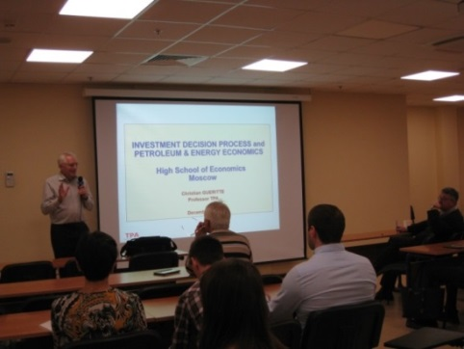
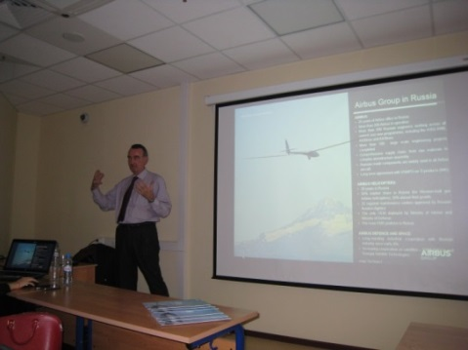

HSE Library
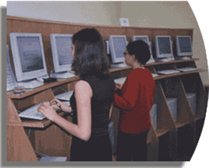
HSE has a large academic library containing material on subjects of instruction at the University. The collection comprises over 700,000 books and periodicals and offers a great variety of electronic resources, including e-books and journals, databases of peer-reviewed literature, patents, business data and other data collections.
The main library with reading halls is situated at 20, Myasnitskaya Street.
More Information: http://library.hse.ru/eng.htm

Guide for international students

Visa
If you plan to go the HSE for studies or internship you should apply for a Student visa to Russia:
1) check the study visa requirements at the Russian consulate in your country of residence.
2) check the steps of the initial visa procedure:
- Specify that you need visa support in the e-mail letter;
- Send a copy of your passport ;
- HSE applies to the Migration Service for an official invitation letter;
- Migration Service issues the invitation letter (usually takes 1-1,5 months);
- Receive the invitation letter and a formal acceptance letter;
- Find out what other documents are needed for the single-entry visa at the Russian embassy/consulate in your current country of residence;
- Apply for a student visa in time before arriving to Russia at the Russian consulate or visa center.
3) apply for a study visa at the Russian consulate according to your student category.

International Students Support
At the beginning of a semester HSE International Students Support Department hold orientation session.
In order to adjust to student life, it is essential that students participate in the Orientation Session as it will provide them with information on studying at HSE, living in Moscow, as well as other useful tips to help them better enjoy your experience in Russia.
What students can expect from the Orientation Session:
- Meeting the HSE International Students Support staff;
- Meeting the HSE Buddies;
- Receiving an orientation pack;
- For all categories of international students: overview of student documents and procedures, visa & registration process, dormitory accommodation, health insurance, cultural adjustment and safety awareness at HSE, in Moscow and Russia in general;
- For exchange & Semester in Moscow students: overview of academic matters and course selection.
- Activities to introduce students to HSE's social and cultural life and student initiatives.
For more information: https://istudents.hse.ru/

HSE Dormitory
We offer our students the HSE Professors’ Guesthouse which is located at 50 Bolshaya Pereyaslavskaya.
It is just a 10-minute walk from the metro station “Prospekt Mira” (orange line) and about 15 minutes from “Prospekt Mira” (brown line).
There are 47 comfortable rooms in the HSE professors’ guesthouse at 50 Bolshaya Pereyaslavskaya: 34 Single and 13 one-bedroom Junior suites. All rooms are non-smoking. Every room is equipped with a shower, TV, phone, refrigerator and double bed (150 – 160 cm).
Special price for longer stays (more than 30 days) – 15 000 rubles per month per single room.
On each floor you may ask the maid for an additional pillow, towel and blanket or water kettle. On the 1st floor you may use a self-service laundry (2 frontload washers, 1 dryer, ironing facilities) and a kitchen. These services are available free of charge every day from 8 am till 11 pm. Also there is a nice cafe on the 1st floor.
On the 1st floor guests can use a work place equipped with PC and MFP. It is free of charge and available 24 hours. To know more please ask the receptionist. Free wi-fi is available at the hotspot areas near the elevators and in hall on the 1st floor.
More information: https://www.hse.ru/en/hotel/pereyaslavskaya

Surroundings of the Dormitory
Shopping:
Small food shops near the metro;
Supermarket in front of the guesthouse;
Shopping center “Olympic Plaza” (open every day from 10 am to 9 pm);
Premium supermarket “Azbuka Vkusa” (open 24/7, Prospekt Mira,58).
Post:
Post office № 129110 (Monday-Friday from 8 am to 1 pm and from 2 pm to 8 pm; Saturday from 9 am to 1 pm and from 2 pm to 6 pm).
Banks:
VTB24 “Prospekt Mira” (Monday-Friday from 9 am to 8 pm; Saturday from 9 am to 5 pm, Prospekt Mira,76/1).
Raiffeisen Bank “Prospekt Mira” (Monday-Friday from 10 am to 8 pm, Bannyy pereulok,3).

For additional information, business enquiries and enrollment please contact:
Dr. Irina Maltseva
Director of the International Institute of Administration and Business
Phone: +7 (495) 621 - 51 - 33
E-mail: maltseva@hse.ru

Maya Gromova
Manager
Phone: + 7 (495) 772-95-90 *22499
Email: mvgromova@hse.ru

