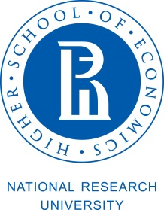

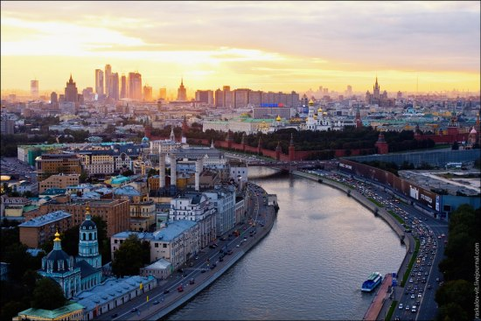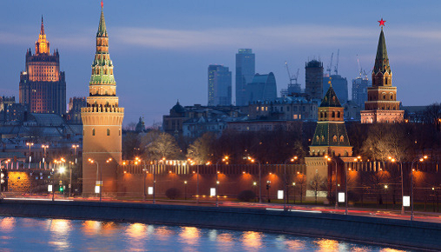

National Research University Higher School of Economics
International Institute of Administration and Business

PROGRAM
«Doing Business in Russia»

Moscow, March – April, 2018
82 contact hours (9 ECTS)

Program language - English

The program “Doing Business in Russia” is designed exclusively for the National Research University Higher School of Economics. The quality of education provided by the leading professors and experts of NRU Higher School of Economics and experts of international companies, members of the Expert and Supervisory Board of the International Institute of Administration and Business of National Research University Higher School of Economics.

Target audience: foreigners who want to learn the basic rules of doing business in Russia, including the specifics of the Russian legislation, the corporate governance and managerial approaches, cross-cultural features of doing business in Russia, as well as an overview of different sectors of economics in different regions of the Russian Federation.

CERTIFICATE: HSE Certificate of short-term professional retraining.

The Program includes master-classes of top managers and visits to multinational and Russian companies, such as:
- Group of companies "Helvet" which is the largest Russian developer, manufacturer and supplier of original complex preparations of its own design for the animals. Today, the products of "Helvet" is widely used and is represented in all regions of Russia and CIS countries (Belarus, Kazakhstan, Ukraine). The group of companies was founded in 1995, the distinctive feature and an absolute competitive advantage is the presence of the group in its structure the scientific units with the possibility of their own research. The Helvet Group actively expands to international market including Brazil and EU countries.
- Schneider Electric, which is a global expert in energy management and automation. Schneider Electric offers integrated energy efficient solutions for energy and infrastructure, industrial enterprises, civil and residential construction, as well as data centers. Divisions of the company successfully operating in more than 100 countries.
JSC "Schneider electric" has offices in 35 Russian cities with headquarters in Moscow. Industrial base of Schneider Electric in Russia is represented by 6 operating plants and 3 logistics centers. Also in Russia there are scientific, technical and engineering centers of the company. The number of employees in Russia is about 12 000.
- TVEMA company, a world leader in the design, manufacture, and distribution of rail safety systems, and Russia's first Centre for practical training lean production (“LEAN Center”), organized on the basis of Training center of TVEMA company by specialists of the consulting lab "Open innovation". The purpose of the Center is to teach students to apply the tools of lean production and other technologies that allow you to optimize production processes to improve operations of businesses and improve their operating efficiency.
Founded in 1989, TVEMA is a rapidly developing international holding with a management company in Moscow, subsidiaries across Russia, and regional representative offices in Germany, China, and Ukraine.
- Skolkovo Technopark.
Technopolis Skolkovo focuses primarily on space technologies and telecommunications as well as biomedical, energy-efficient and nuclear technologies.
A total of 1065 tenant companies from all over Russia are registered with Skolkovo and 81 of them are residents of the technopolis. Resident companies have created over 1 000 jobs. The Skolkovo Innovation Center will be home to almost 25 000 people by 2025, with over 30 000 visiting the technopolis on a daily basis.
Technopolis Skolkovo offers its residents a unique ecosystem of innovation at one location as well as innovative infrastructure, R&D centres, grant support, mentor and acceleration programs, and opportunities for international expansion.

CONTENT

Course № 1 “Economic Context of Doing Business in Russia” (12 contact hours/ 2 ECTS )
The module covers the problems of sustained economic growth, including allocation, accumulation, depletion and mobility of natural, physical and human resources in Russia. From the Soviet heritage through the transition period to modern times we survey the political and social background of economic policies. Given path dependent industry structure and social preferences for redistribution we analyze competition and regulatory policies, institutional and structural reforms, fiscal and monetary policies helping students to appreciate the impact of economic environment on strategic and operational managerial decisions in Russia.

Course № 2 “International Dimentions of Organizational Behavior” (12 contact hours/ 2 ECTS)
Russian Business Traditions: Built-in and Newly Established

- Foreign stereotypes and clichés of Russia and Russians
- Russian moral values and norms of behaviour
- Domestic and foreign partnerships and joint ventures
- Cross-cultural communication and international projects
- Business à la russe: An insight

Course № 3 “Russian Businesses: Challenges and Opportunities” (24 contact hours/2 ECTS)

Concept Note:
Russian corporate sector was formed just 25 years ago and had to survive uneasy years of the country’s transition from planned economy to market economy, but does this mean that there was no management tradition and practice in Russia before 1991? Which experience and best practices did Russian firms adopt in 1990s and developed through 2000s? What is the current business environment and infrastructure of corporate governance and strategic management in Russia? These and many other questions will be set and answered during a short course “Russian Businesses: Challenges and Opportunities”. Along with traditional classes, interactive discussions and analyzing business cases, the course includes site-visits to Russian companies of various industries and scale of operations and detailed dialogues with their founders and top-managers.
Course № 4 “Government-Public Relations and Lobbying” (10 contact hours/1 ECTS)
The module has both theoretical and practical application. The module goal is to provide business professionals with the knowledge of various lobbying tools and techniques used by businesses to promote and defend their interests towards all public actors in Russia. It will cover main issues public affair team member has to deal with in Russian business realities as well as deliver a complete set of competences and skills necessary to increase company public reputation and boost local support of authorities. The practice of lobbying actions of Renault Russia will be presented with description of unique cases that ensured the company business success in Russia.

Course 5 “Fundamentals of Entrepreneurship” (24 contact hours /2 ECTS)

The course «Fundamentals of Entrepreneurship» is aiming at two main objectives. Objective number one – is to enable participants to turn their ideas into revenue – generating business, as a family enterprise, startup, or in a corporate environment. Objective number two is to help participants discover their potential as entrepreneurs by making more understandable of what it takes and how to manage it.

For registration please contact:

Maltseva Irina: +7 (495) 621-51-33;
e-mail: maltseva@hse.ru

Gromova Maya: mvgromova@hse.ru

